Overview
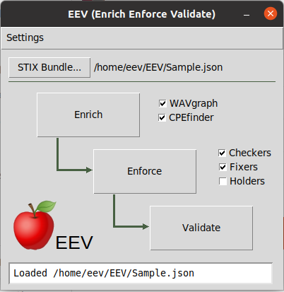
EEV currently exists as a Python script/application which is designed to ingest a user supplied STIX bundle and apply various enrichment, enforcement, and validation to enhance the supplied bundle. The enhanced bundle can then be used for better detection, protection, and sharing of threat data.

Major Components
- WAVgraph
- CPEfinder (Included)
- STIXEnforcer
- STIX2Validator

Dependencies Installation
Modules:
EEV’s major components have minor dependencies. These dependencies can be resolved with the following commands:

pip install nvdlib
pip install pandas
pip install stix2
sudo apt install python3-tk

WAVgraph:
Install STIG with Neo4j from GitHub (https://github.com/idaholab/STIG)
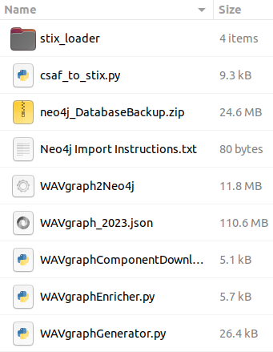
cd /path/to/STIG
docker-compose up

Ensure WAVgraphEnricher directory exists in the EEV folder and contains WAVgraphComponentDownloader.py, WAVgraphGenerator.py, WAVgraphEnricher.py, csaf_to_stix.py and the stix_loader directory.

Executing WAVgraphComponentDownloader.py will download all of the needed components for later generation of the WAVgraph.json bundle. The downloads will include CVE, CAPEC, ATTACK, CWE, KEV, and CSAF details.

python WAVgraphComponentDownloader.py

Note: If the script appears frozen while processing an individual CSAF file, pressing CTRL+C will terminate the conversion of that file and allow the script to continue.

Once the needed components are downloaded WAVgraphGenerator.py can create the WAVgraph.json bundle by specifiying the locations of the various components:

python WAVgraphGenerator.py <CWE csv path> <CAPEC csv path> <ATTACK csv path> <KEV csv path> <CVE JSON Directory> <CSAF JSON Directory> <Output JSON Path | WAVgraph.json>

The final step for WAVgraph is to load the WAVgraph.json bundle into Neo4j where the details can be later queried by WAVgraphEnricher.py through the EEV GUI.

python Stix2Neo4j.py /path/to/WAVgraph.json

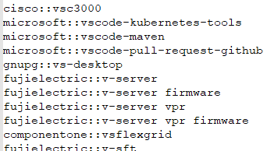
CPEfinder:
Make sure CPEfinder directory exists in the EEV folder and contains CPE_Finder_EVE.py and a list of Vendor::Product pairs from the NVD CPE Dictionary in .csv format. The product pairs can be generated using the CPE_Dictionary_Generator.py script, and CPE_Finder_EVE.py will be executed through the EEV GUI.

python CPE_Dictionary_Generator.py

STIXEnforcer:
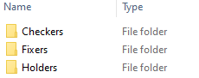
Make sure STIXEnforcer directory exists in the EEV folder and must contain STIX_Enforcer.py and folders for Checkers, Fixers, and Holders. The scripts contained in these folders as well as the STIX_Enforcer.py script will be executed by the EEV GUI.

STIX2Validator:
The STIX2Validator is installed via the following command and is accessed via the EEV GUI directly as a Python library.

pip install stix2-validator

Usage
Once EEV is fully installed and all dependencies are met the EEV GUI can be started with the following command:

python EEV.py

An overview of the three main features of EEV are detailed below in their respective sections.

Enrich:
Enrichment consists of two separate scripts: WAVgraph and CPEfinder each of which can be toggled on/off independently. WAVgraph locates Vulnerability SDOs within a STIX bundle and attaches all associated weaknesses, vulnerabilities, attack patterns, etc. An example is seen below. CPEfinder also locates vulnerability SDOs and enriches each by adding additional potential CPEs and CVEs based on the content of the vulnerability description.
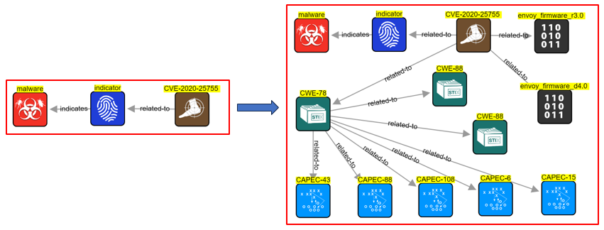
Enforce:
Enforcement consists of a series of scripts which apply various common fixes, check for common errors, and apply default place holding values to objects within the STIX bundle.

Validate:
Validation utilizes the STIX2 Validator to compare the contents of the input bundle to the STIX2 Schema which dictates the required fields and components for a properly formed STIX bundles. If errors are present, they are displayed to provide the opportunity to fix any errors.

